

Purplebit



**Logic Game**

Contents

1. Team 3

1.1 Krasimira Ruseva 9B – Scrum Trainer 3

1.2 Elena Keserdzhieva 9A – Backend Developer 3

1.3 Vanesa Kardzheva 9A – Backend Developer 3

1.4 Rumen Petkov 9V – Q&A Engineer 3

2.Goals 4

3. Stages of development 4

3.1 Start of the project and planning 4

4.Stages of realization 5

4.1 Planning 5

4.3 Testing 5

5. Site description and structure 6

5.1 Structure 6

5.2 Description 7

6.Table with functions and explanations 7

# 1. Team

# 1.1 Krasimira Ruseva 9B – Scrum Trainer

I am the leader and I organized my team. I worked on the presentation and on the docomentation. I created the repo and the files inside so that my team could work on them. I made projects and issues so we could work better.

# 1.2 Elena Keserdzhieva 9A – Backend Developer

I worked on C++ code. I made part of the menu of the game and the logic.Together with Vanesa we made the cards draggable and helped each other when there were some problems.And I made cards assets.

# 1.3 Vanesa Kardzheva 9A – Backend Developer

I worked on the C++ code. I made the other part of the menu of the game and the logic. Also I add comments to the code, made logo and the playmat. Together with Elena we made the cards draggable.

# 1.4 Rumen Petkov 9V – Q&A Engineer

I made test cases which I included in the QA documentation. With them I checked if the code works and when there were errors, they were solved. I also made the test and have to think different ways of "breaking" the code.

Интр

# 2.Goals

Our goal is to create the game Booleo using C++. That is game with cards which, are only with 0 and 1.

We tried to create the game Booleo in an interesting and educational for all people way, so people who want to use it to become interested in programming and to learn about boolean operations. We want our game to be useful for our visitors and help them to develop starting knowledge related to programming.

# 3. Stages of development

# 3.1 Start of the project and planning

After we formed our team, we got together and decided what everyone's role is, and then the leader of our team registered us. We decided when we are going to have meetings and then we were ready to start.

We started our work using Microsoft teams as communication platforms. We discussed ideas and gave different suggestions on how each of us sees the final product. After we reached a consensus, we decided what part of the project everyone should do and we started working. If there were any problems we helped each other in the process of work.

# 4.Stages of realization

# 4.1 Planning

After we formed our team and assigned the roles, and we organized when our meetings would take place.

**4.2 Realization**

We decided what is the project going to include. During the whole process we used MS Teams to communicate with one another. We met frequently to discuss about the progress, the due dates that the Scrum Trainer assigned and helping one another.

# 4.3 Testing

Our Q&A Engineer made sure that all used functions, cycles work and pointed out the bugs and mistakes, so that they could fixed as soon as possible**.**

# 5. Site description and structure

# 5.1 Structure

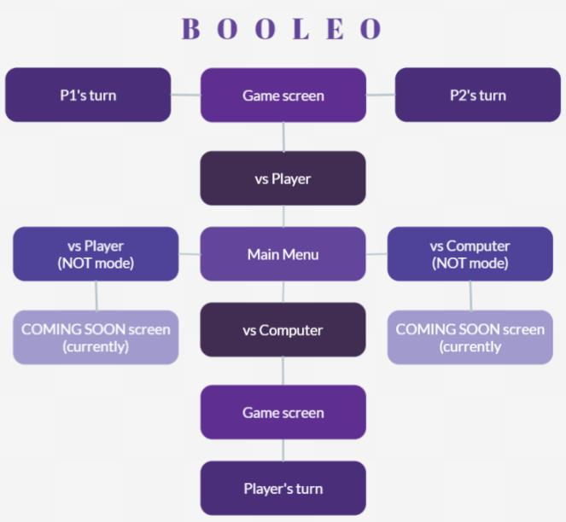

# 5.2 Description

Here in our game, you will find the menu of the game from which you can choose between four different modes of playing Booleo when you place the cursor on the mode’s name. And after that you will be redirected to the playmat where there are the cards the player fields. There you can play with the cards by dragging them. And if the card can be placed in some the places because of its number, it will be returned to its first position.

# 6.Table with functions and explanations

|  |  |
| --- | --- |
| Function name | Description |
| void ShowHome() | Prints home screen window. |
| RenderWindow::RenderWindow() | Renders a window. |
| SDL_Texture* RenderWindow::loadTexture() | Loads texture. |
| int RenderWindow::getRefreshRate() | Gets refresh rate. |
| void RenderWindow::cleanUp() | Cleans everything by destroying window. |
| void RenderWindow::clear() | Clears window by removing rendered objects. |
| SDL_Window* RenderWindow::getWindow() | Returns window value. |
| void RenderWindow::render() | Declares render. |
| void RenderWindow::display() | Renders a display. |
| ENTITY::ENTITY() | Declares proper entity values. |
| float ENTITY::getX() | Returns the current x coord. |
| void ENTITY::setX() | Modifies x. |
| float ENTITY::getY() | Returns current y coord. |
| void ENTITY::setY() | Modifies y. |
| void ENTITY::drag() | Tells the program how drag function works. |
| void ENTITY::controlDrag() | Controls dragging cards. |
| void ENTITY::setDraggable() | Makes draggable possible. |
| bool ENTITY::isMouseClicked() | Checks if the left mouse button is clicked. |
| bool ENTITY::getDrag() | Returns if draggable. |
| SDL_Texture* ENTITY::getTex() | Returns texture. |
| SDL_Rect ENTITY::getCurrentFrame() | Returns the current frame. |
| SDL_Texture* OBJECT::getTexture() | Returns tex variable. |
| SDL_Rect* OBJECT::getSrc() | Returns src variable. |
| SDL_Rect* OBJECT::getDest() | Returns dest variable. |
| void OBJECT::setSrc() | Giving values to variables using arrow operator from src pointer. |
| void OBJECT::setDest() | Giving values to variables using arrow operator from dest pointer. |
| void OBJECT::CreateTexture() | Giving a value to a variable called tex. |
| SDL_Texture* TextureManager::Texture() | Explains proper texture values to program. |